Dear reader,
If you’ve ever seen the video the “Annoying Orange” then you’ll love this! The “Annoying Orange” is like my mentor text but-my mentor video.
Enjoy,
Campbell

Hay. Hay. Down here. I’m talking to you. I know there’s nobody listening but, I don’t care. You might think I’m bossy. I don’t really care, real surprise right. Don’t be smart with me. Don’t put me down. Fine then put me down. See if I care. (Please don’t……. you’re all I have.)
The Series of Very Annoying Foods

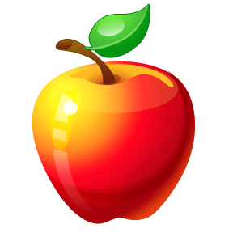
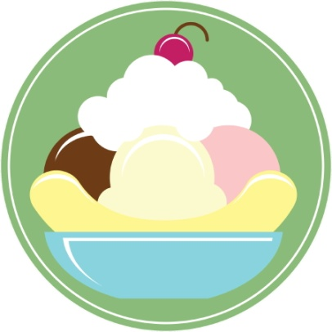



By: Campbell Matz

The Annoying Apple
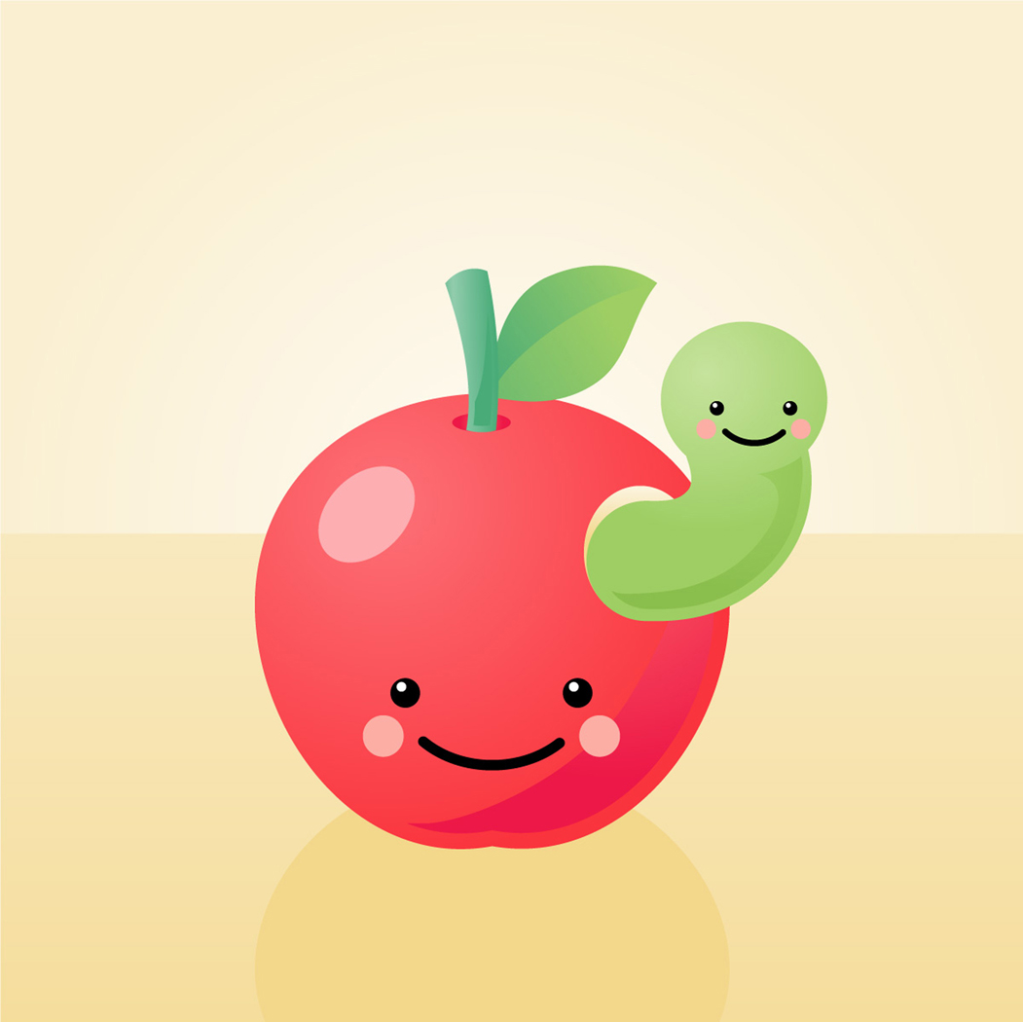
Gotta go, my mom’s coming. She’s so mean. I don’t like it when she’s mean to me. When she is, I ignore her.
* Several hours later*……..
People are usually annoyed by me. Everyone’s ignoring me. I DON’T LIKE IT!

The Bad Boy Banana
Yo! What up? Are you a nerd or something? Because, you look smart to me. I don’t like smart people. You know why? I ain’t smart. So spread the word if you want-but you’ll get it.
Sometimes they ignore me. It’s not fun when people don’t care when you boss them around. Ain’t isn’t a word they say. But I don’t care. They’re ignoring me again. I don’t like it. Gotta go, got to beat up a new banana. See ya. Banana out! Peace.
*Many hours later*………..
Nobody’s afraid of me today. This is frustrating. I HATE THIS!
(Hate it!)
Hay. Hay. Hay. I’m from the city. We in the city can do awkward things. Like run across the street, bump into people, but the worst possible thing we can do is….. NOT CARE!
Sometimes people who are no fun just ignore us. It gets to be NO fun! Some of us don’t care about things like school-like me. In case you don’t know…I’m the apples cousin. Don’t push my buttons or I’ll push yours. So don’t. Okay?
*One day later*……..
No one is being mad at me from my city talk. It’s bothering me… A LOT! I guess I have to be kind of nice now. That’s the only way people will notice me. I have to do it. Wish me luck.
*One day later*…
Everyone is noticing me. Yea! Thanks for the good luck. Bye!
The City Cake

The Drama Queen Dessert

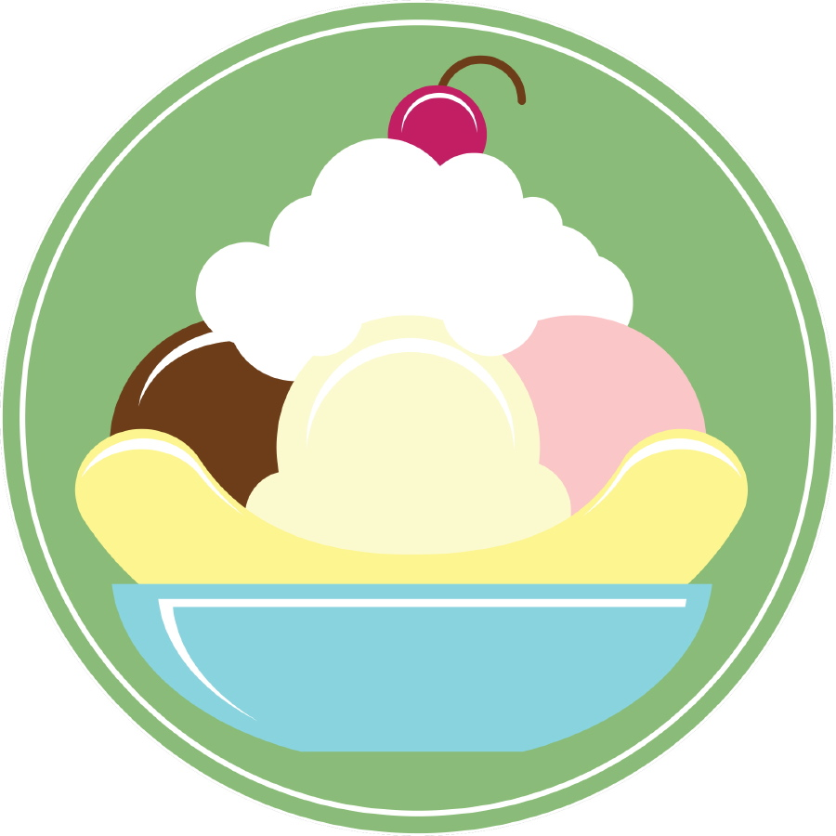

I’m the apples cousin. (Who is SO annoying by the way).SO this title, I personally don’t like it. The person who wrote this is SO mean. I only get crabby when people ignore me. I mean having a tub the size of a hotel pool and a helicopter that brings me to school in China when I don’t want to use my private jet doesn’t mean I’m a drama queen. Right? Right!!!

I still don’t like it when people ignore me. How come my jet or helicopter isn’t here? I don’t like this. Is he ignoring me. He’s making me sad.
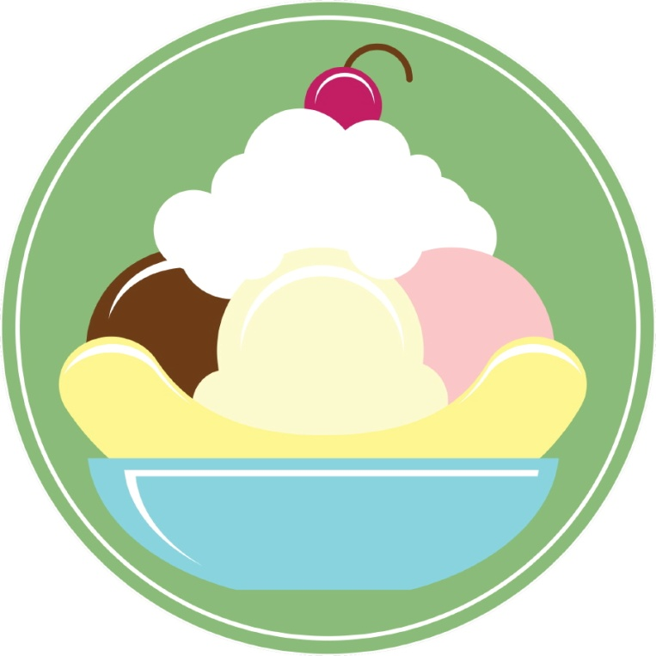
*Several hours later*…
The dessert is now crying.
The Sassy Spaghetti

Man! Do people have any manners? I mean the Drama Queen Dessert is SO mean. She’s my sister, she can get really, really ANNOYING! Just like my cousin the annoying apple. I mean what’s so cool about an apple. My sister sometimes ignores me when I’m mean to her. Anyway, apples are red, hard, and kind of fat. Who would ever like him?
He’s really cold and ANNOYING! (I repeat ANNOYING!)
*One day later*……….
Why is nobody listening to me to me? Isn’t anybody ignored by me sass? I seriously don’t like this. I don’t want to be a drama queen like my sister but-…. I don’t like this!

This story is about how a variety of related food that has some stories of their own.
I hope you enjoy,

Campbell

